**2.AWS Elastic Beanstalk**

AWS Elastic Beanstalk is an easy-to-use service for deploying and scaling web applications and services developed with Java, .NET, PHP, Node.js, Python, Ruby, Go, and Docker on familiar servers such as Apache, Nginx, Passenger, and IIS.

We can simply upload your code and Elastic Beanstalk automatically handles the deployment, from capacity provisioning, load balancing, and auto-scaling to application health monitoring. At the same time, you retain full control over the AWS resources powering our application and can access the underlying resources at any time. There is no additional charge for Elastic Beanstalk for the AWS resources needed to store and run our applications.

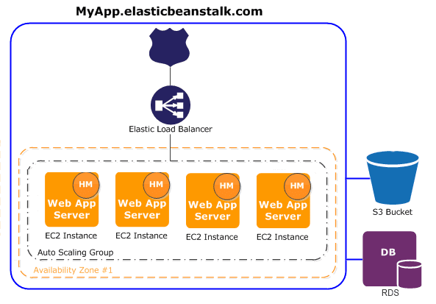

**Few key concepts related to Elastic Beanstalk:**

* An application is a logical collection of Elastic Beanstalk components, including environments, versions, and environment configurations. An application can have multiple versions.
* An environment is a collection of AWS resources running an application version.
* A platform is a combination of an operating system, programming language runtime, web server, application server, and Elastic Beanstalk components.

**Benefits of AWS Elastic Beanstalk**

* AWS EBS offers a simple and quick way to deploy web applications.
* With EBS, you can focus on your application code rather than provisioning and configuring AWS resources.
* Auto-scaling settings on EBS help automatically scale the application.
* One has control over all the AWS resources like EC2 that are powering the app.
* AWS EBS provides a cost-effective price in which one has to pay for what one uses and there are no hidden costs.
* AWS EBS supports Java, .NET, PHP, Node.js, Python, Ruby, Go, and Docker web applications.
* Access to monitoring metrics like CPU utilization, request count, and latency.

**Deploying a Flask App on AWS Elastic Beanstalk:**

**Steps to Follow for Deployment:**

* Building a Flask API
* Creating a Requirements.txt file
* Creating an application on AWS Elastic Beanstalk
* Creating an Environment